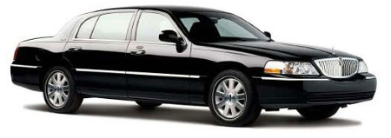
1-877-344-2517
Ph# (973) 402-8923
Fax# (800) 453-8280
E-Mail: alertlimo@verizon.net

CREDIT CARD AUTHORIZATION FORM

FOR MY CONVENIENCE, I AM AUTHORIZING “ALLERT LIMOUSINE SERVICE” TO EXECUTE TRANSCATIONS FOR TRANSPORTATION SERVICES ON MY:

American Express Mastercard Visa Discover Diner
(Please Circle One)

Transcation executed on my behalf will read “Signature On File” on the Signature Line of the Credit Card Voucher. By executing this Document, it will not be necessary for me to sign each Credit Card Voucher.

Cardholders’ Name/Company: ______________________________________________
Credit Card #: ___________________________________ Exp. Date: _______________
CVV* ______ *CVV is the last 3 digits on the back of your card. For Amex it’s the 4-digit code on the front side.
Billing Address: __________________________________________________________
Telephone: _____________________________ E-Mail: __________________________

I authorize Allert Limousine Service to charge all expenses related to all reservations made by me. I understand that if I cannot locate my driver, it is my responsibility to call the Allert Limousine dispatcher at 1-877-344-2517. Failure to call Allert Limousine and leaving a pickup location will result in a no-show charge to my credit card. No-show charges may include full payment for my reservation, and up-to 45 minutes waiting time. I understand that if I wish to cancel my reservation, it is my responsibility to notify Allert Limousine at least 12 hours before reservation time. Failure to do so will result in late cancellation charge to my credit card. Late cancellation fee is equal to full reservation fare. Also, for Stretch or Van the cancellation should be done at least 24 hours before reservation time. Please fax this authorization to Allert Limousine 1-800-453-8280 along with a clear copy of both sides of your credit card and a photo I.D. we will not process pre-payment request without complete documentation. This authorization is valid until such time as written notice of revocation is received by the “Allert Limousine Service.”

Card Holder Signature: ________________________________ Date: _____________
Allert Limousine Service, LLC
Toll Free: 877-344-2517 * Phone: 973-402-8923 * Fax: 800-453-8280
www.alertlimo.com

